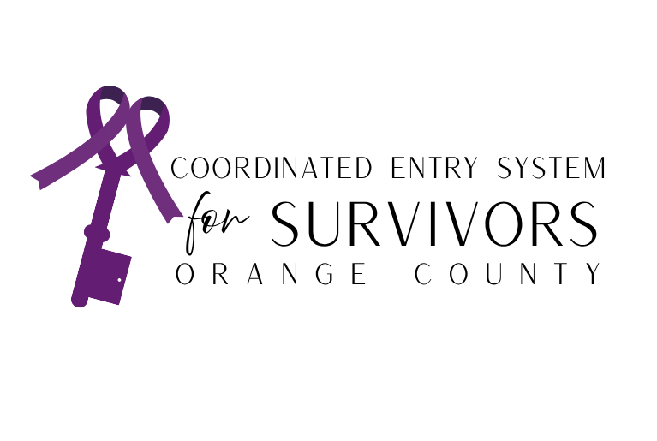

***Victim Service Provider (VSP) Access Point requirements***

VSPs participating in Orange County’s SCES serve as access points to connect survivors of domestic violence, human trafficking, and other forms of interpersonal violence to trauma-informed housing services. VSPs agree to follow specific requirements to ensure access to housing is safe, equitable, and survivor centered.

1. Each SCES Victim Service Provider Access Point must send at least one agency representative to SCES Case Conferencing, Office Hours, and other applicable collaborative meetings. Representatives are responsible for presenting the housing needs of their enrolled participants, confirming or declining housing matches, and supporting case coordination across systems.

2. All VSP staff must obtain SCES comparable database access authorization before discussing any Personally Identifying Information (PII). Survivor PII shall only be shared with written, informed consent. SCES prioritizes safety, consent, and confidentiality in all data practices.

3. SCES is a housing-focused, person-centered system that upholds the principles of Housing First, Harm Reduction, and Trauma-Informed Care. VSPs are expected to prioritize survivor safety, choice, and self-determination while minimizing barriers to housing access throughout the SCES process.

4. VSP Access Points are responsible for maintaining accurate and timely data using SCES forms and tools. This includes, but is not limited to:

* Completing Pre-Assessment Tools and SCES Survivor Assessments
* Entering and maintaining Current Living Situation (CLS) forms
* Submitting Referral Request Forms
* Completing SCES Exit Forms when a participant:
  + Household is no longer in contact with VSP
  + Household self-resolves their experience or episode of homelessness
  + Household is housed through SCES
  + Household is matched to housing outside of SCES
* Updating agency contact information and assigned Care Team members as necessary

5. VSP Access Points must review and correct their agency’s SCES data on a regular basis to ensure accuracy and alignment with SCES guidelines. This includes updates to participant records, enrollment status, housing progress, household exits, and staff assignments.

6. VSPs accepting SCES matches are expected to support participants throughout the housing navigation, housing application, and move-in process. Responsibilities include:

* Assisting survivors in completing housing applications
* Collecting and submitting required housing documentation
* Communicating proactively with SCES Administrators and Housing Providers about participant status
* Responding to SCES match notifications in a timely manner to confirm, decline, or request additional time

7. SCES VSP Access Points are encouraged but not required to ensure their agency’s programs are listed accurately in the 2-1-1 Resource Database and reviewed annually. This ensures coordinated access and referral support across the system.

8. Each VSP Access Point must designate one SCES Agency Administrator and one backup who will be responsible for:

* Providing training and support to agency staff involved in SCES
* Reviewing agency data regularly and managing data quality
* Attending annual SCES Agency Administrator training
* Ensuring agency compliance with SCES and CES policies and procedures
* Serving as the main point of contact for SCES Administrators and Housing Providers for troubleshooting or support

9 VSP Access Points are encouraged to participate in CES Steering Committee meetings to contribute to system-wide planning, ensure that survivor voices are represented, and remain informed about CES-related policy changes and procedures.

10. In addition to the items listed above, SCES VSP Access Points agree to:

* Conduct and submit Survivor Assessments using SCES-approved tools
* Assist participants in completing CES Authorization Forms and VSP Certifications
* Maintain active enrollment and survivor engagement
* Coordinate with survivors to respond to match offers in a timely manner
* Collect and support submission of housing documentation
* Complete SCES Exit Forms accurately and in a timely manner

